CREATE A WEB PROJECT

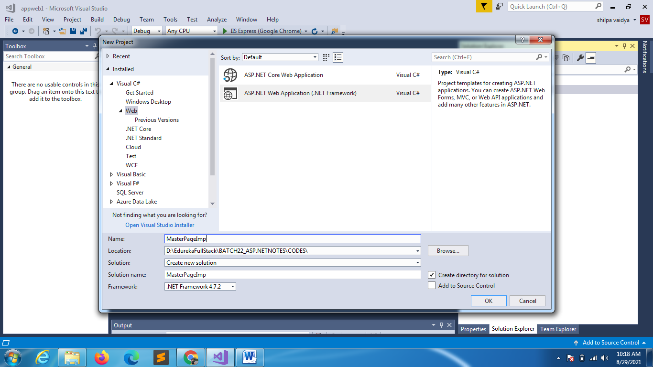

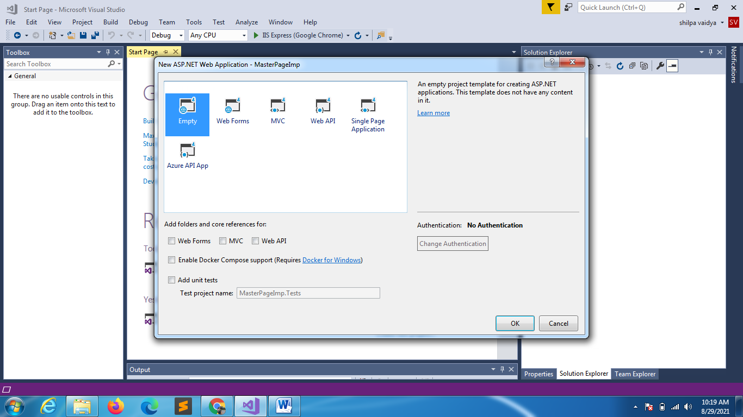

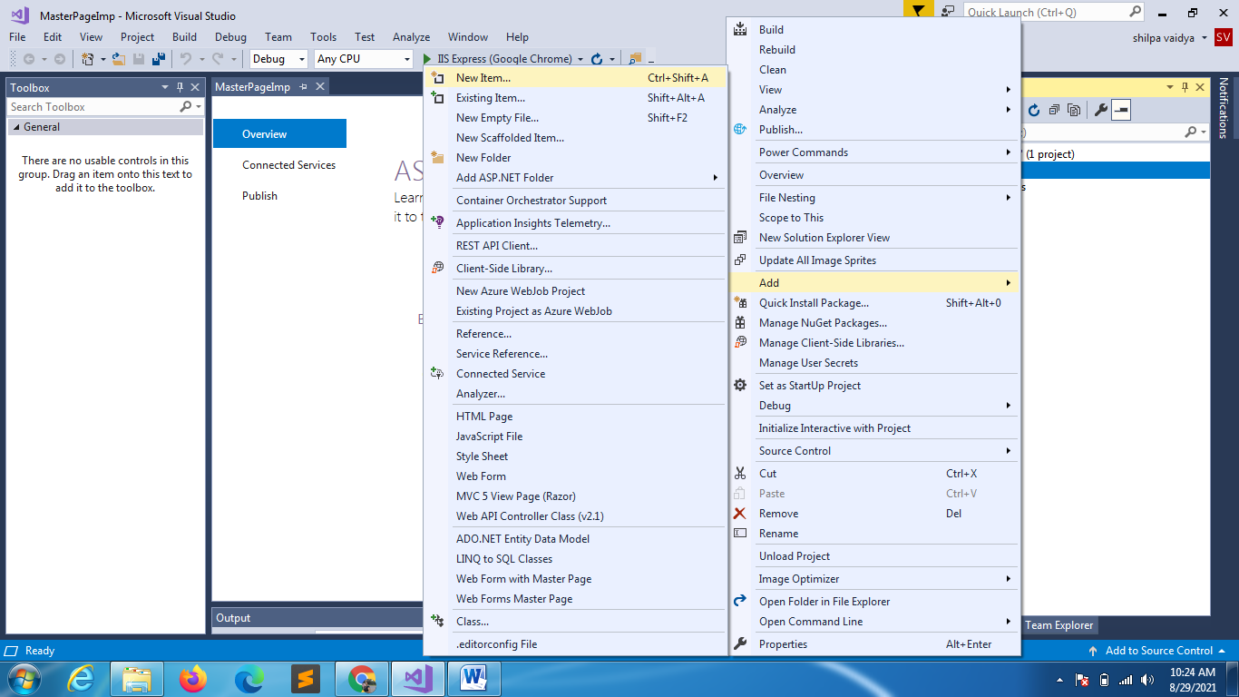

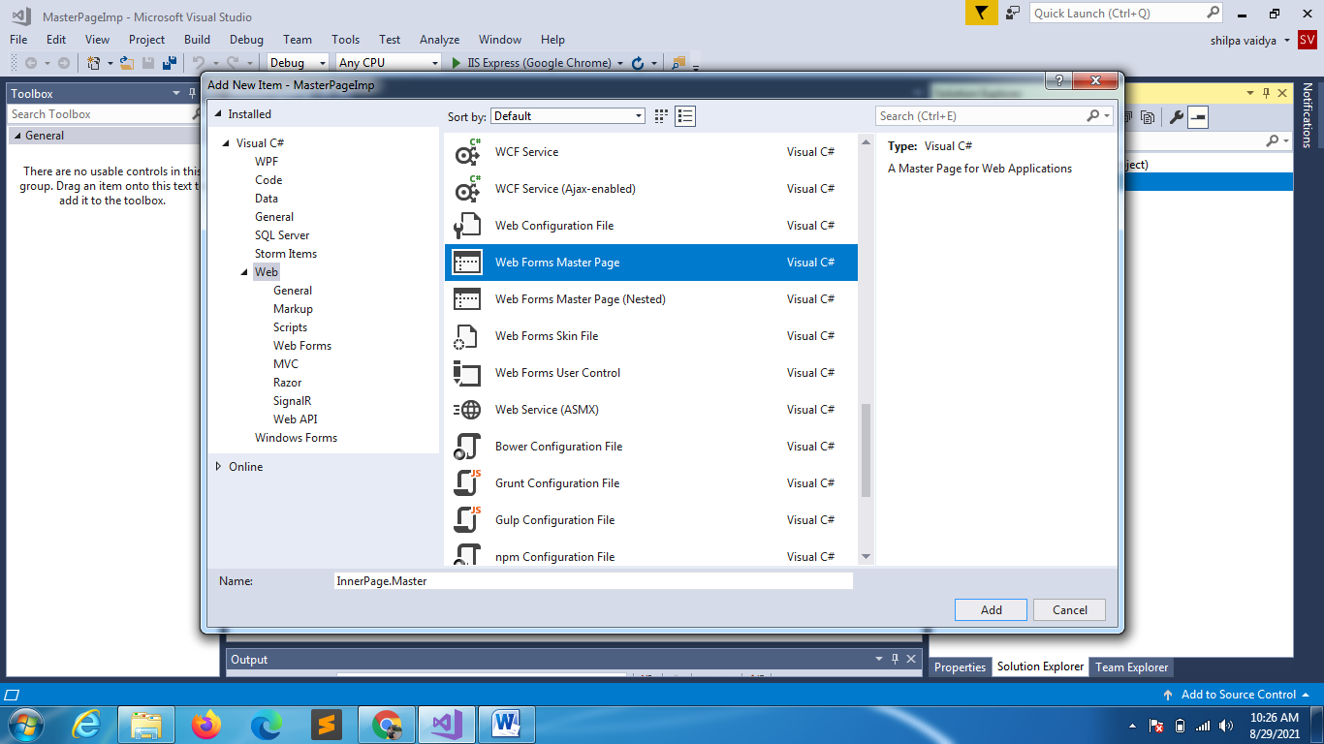

<%@ Master Language="C#" AutoEventWireup="true" CodeBehind="InnerPage.master.cs" Inherits="MasterPageImp.InnerPage" %>

<!DOCTYPE html>

<html>

<head runat="server">

    <title></title>

    <asp:ContentPlaceHolder ID="head" runat="server">

    </asp:ContentPlaceHolder>

</head>

<body>

    <form id="form1" runat="server">

        <div>

            <asp:ContentPlaceHolder ID="ContentPlaceHolder1" runat="server">

            </asp:ContentPlaceHolder>

        </div>

    </form>

</body>

</html>

**AutoEventWireup attribute in ASP.NET**

<%@ Master Language="C#" AutoEventWireup="true" CodeBehind="InnerPage.master.cs" Inherits="MasterPageImp.InnerPage" %>

The ASP.NET page framework supports an automatic way to associate page events and methods. If the AutoEventWireup attribute of the Page directive is set to true, the page framework calls page events automatically, specifically the Page_Init and Page_Load methods. In that case, no explicit Handles clause or delegate is needed.

 Code Behind refers to **the code for an ASP.NET Web page** that is written in a separate class file that can have the extension of . aspx. cs or . ... One major point of Code-Behind is that the code for all the Web pages is compiled into a DLL file that allows the web pages to be hosted free from any Inline Server Code.

Use the Inherits attribute with precompiled classes. If you precompile your code-behind classes into an assembly, you can use the Inherits attribute to **specify the class from which to inherit**. In this scenario, you do not have to include the actual code-behind class file when you deploy the application.

Delete the content holder

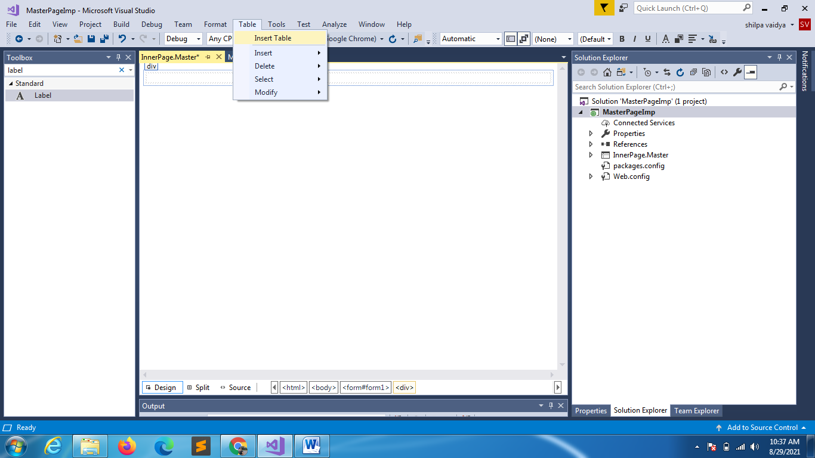

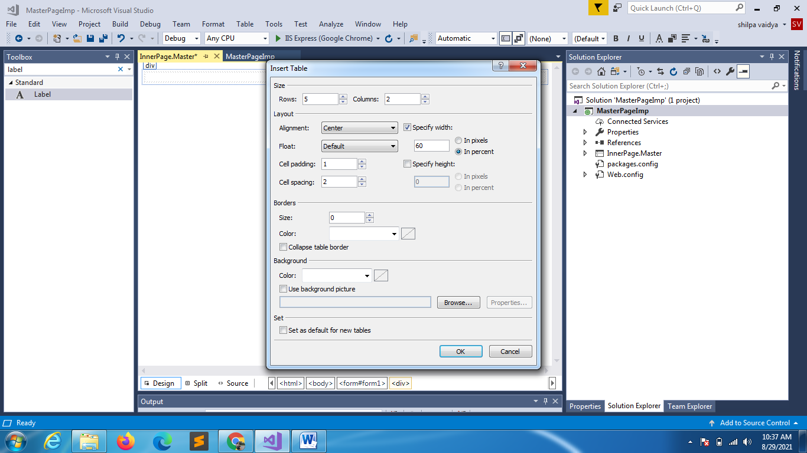

Merge first and last row

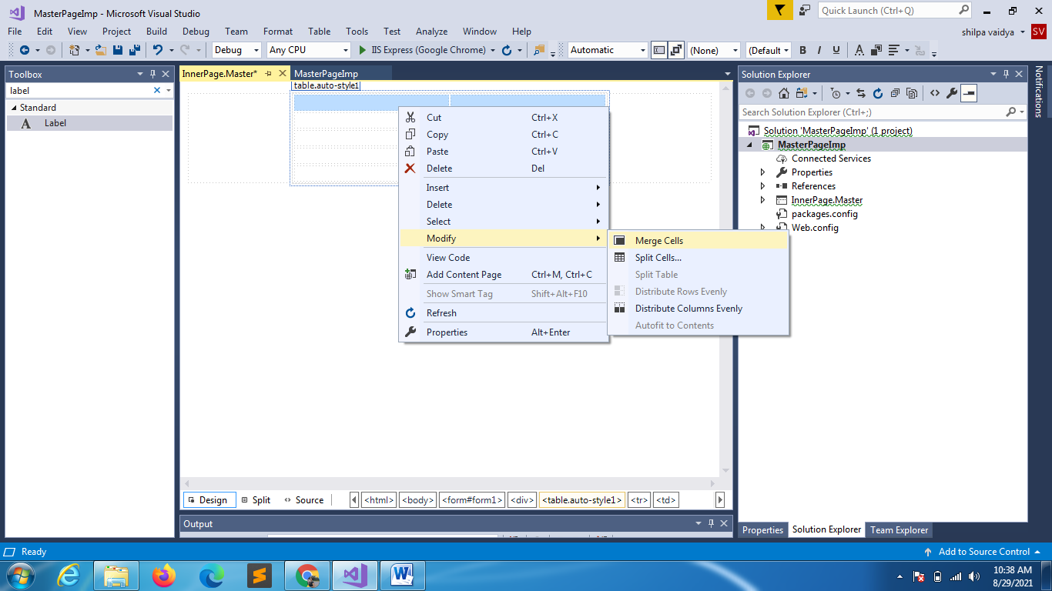

Merge Second row and provide ContentPlaceHolder

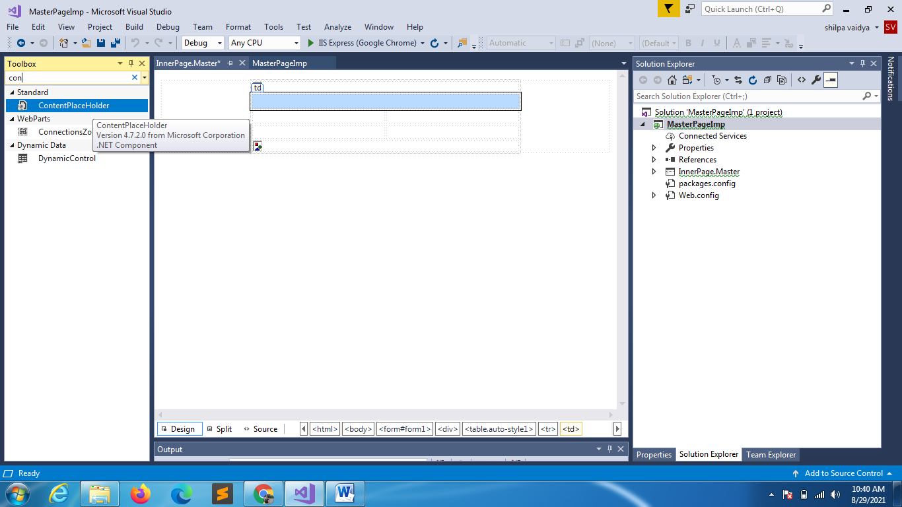

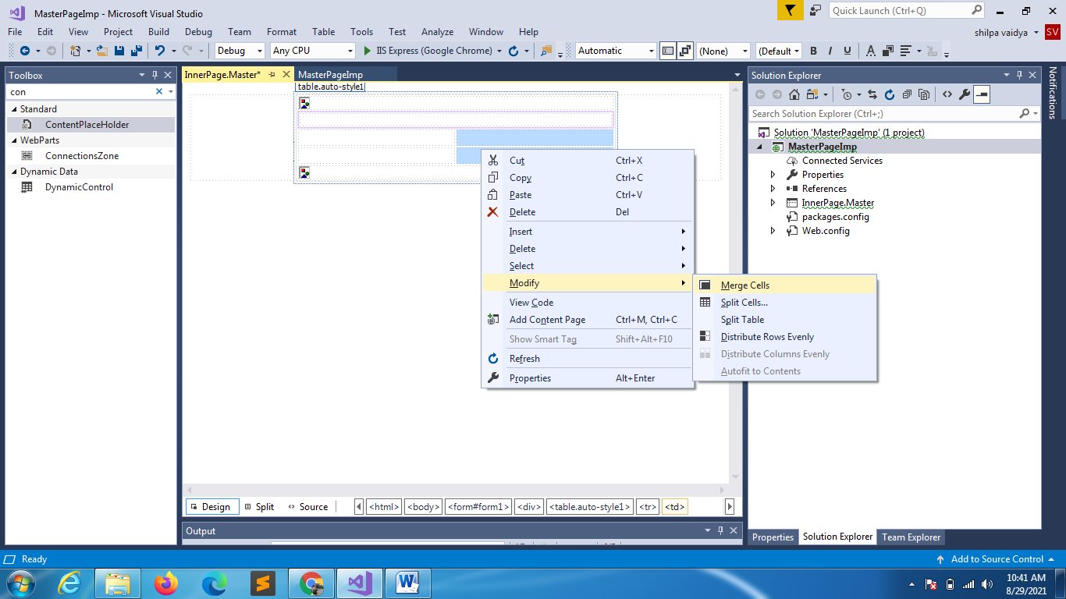

2ND ROW

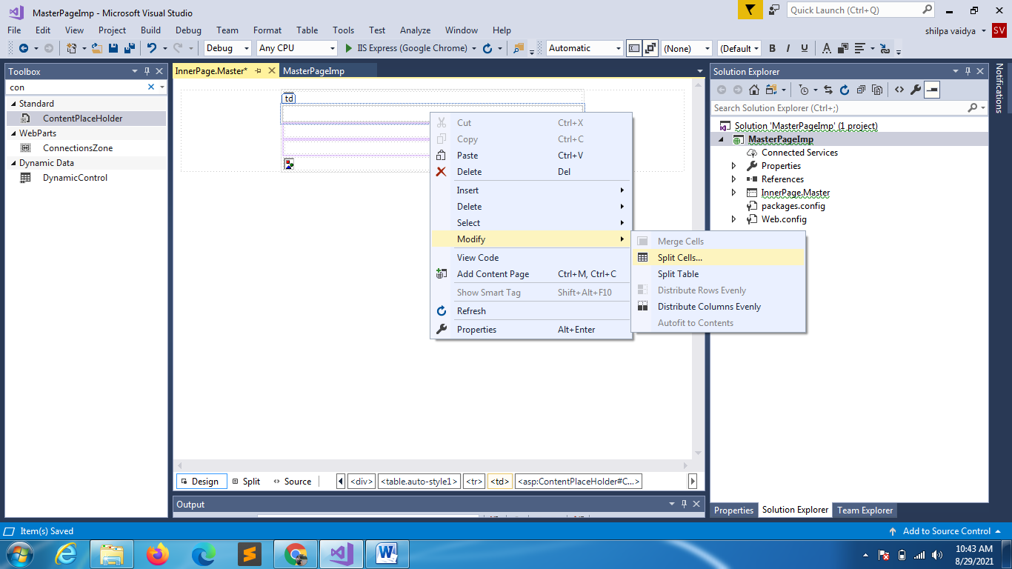

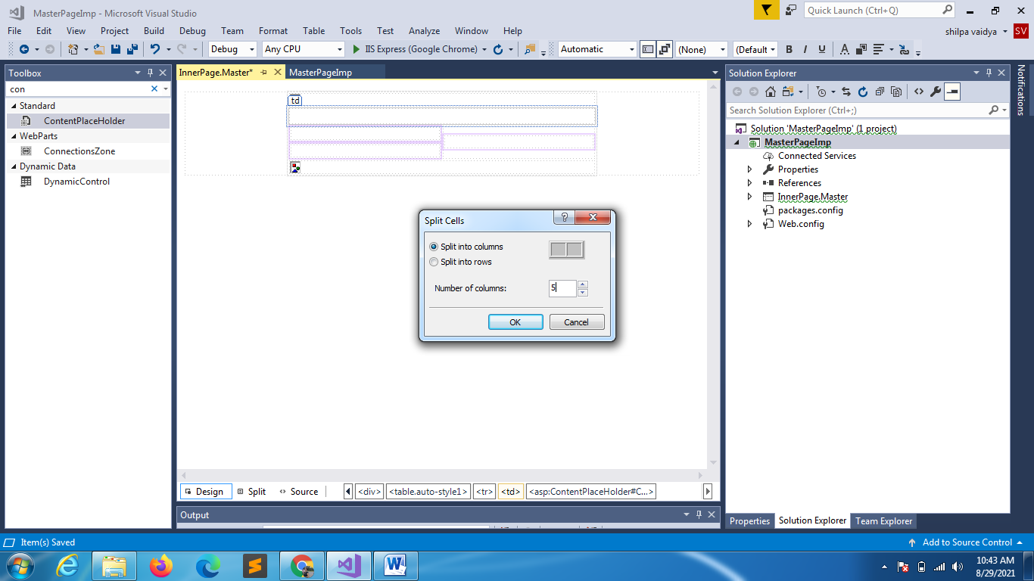

Have PROVIDED CONTENT PLACEHOLDERS 3

<%@ Master Language="C#" AutoEventWireup="true" CodeBehind="InnerPage.master.cs" Inherits="MasterPageImp.InnerPage" %>

<!DOCTYPE html>

<html>

<head runat="server">

    <title></title>

    <asp:ContentPlaceHolder ID="head" runat="server">

    </asp:ContentPlaceHolder>

    <style type="text/css">

        .menulist li

        {

            font-size:15px;

            width:20%

        }

    </style>

</head>

<body>

    <form id="form1" runat="server">

        <div>

            <table align="center">

                <tr>

                    <td colspan="6">

                        <asp:Image ID="Image1" runat="server" />

                    </td>

                </tr>

                <tr class="menulist">

                    <td>HOME</td>

                    <td>ABOUT</td>

                    <td>PROJECT</td>

                    <td>TEAM</td>

                    <td>CONTACT</td>

                </tr>

                <tr>

                    <td colspan="3">

                        <asp:ContentPlaceHolder ID="ContentPlaceHolder2" runat="server">

                        </asp:ContentPlaceHolder>

                    </td>

                    <td colspan="3" rowspan="2">

                        <asp:ContentPlaceHolder ID="ContentPlaceHolder4" runat="server">

                        </asp:ContentPlaceHolder>

                    </td>

                </tr>

                <tr>

                    <td colspan="3">

                        <asp:ContentPlaceHolder ID="ContentPlaceHolder3" runat="server">

                        </asp:ContentPlaceHolder>

                    </td>

                </tr>

                <tr>

                    <td colspan="6">

                        <asp:Image ID="Image2" runat="server" />

                    </td>

                </tr>

            </table>

        </div>

    </form>

</body>

</html>

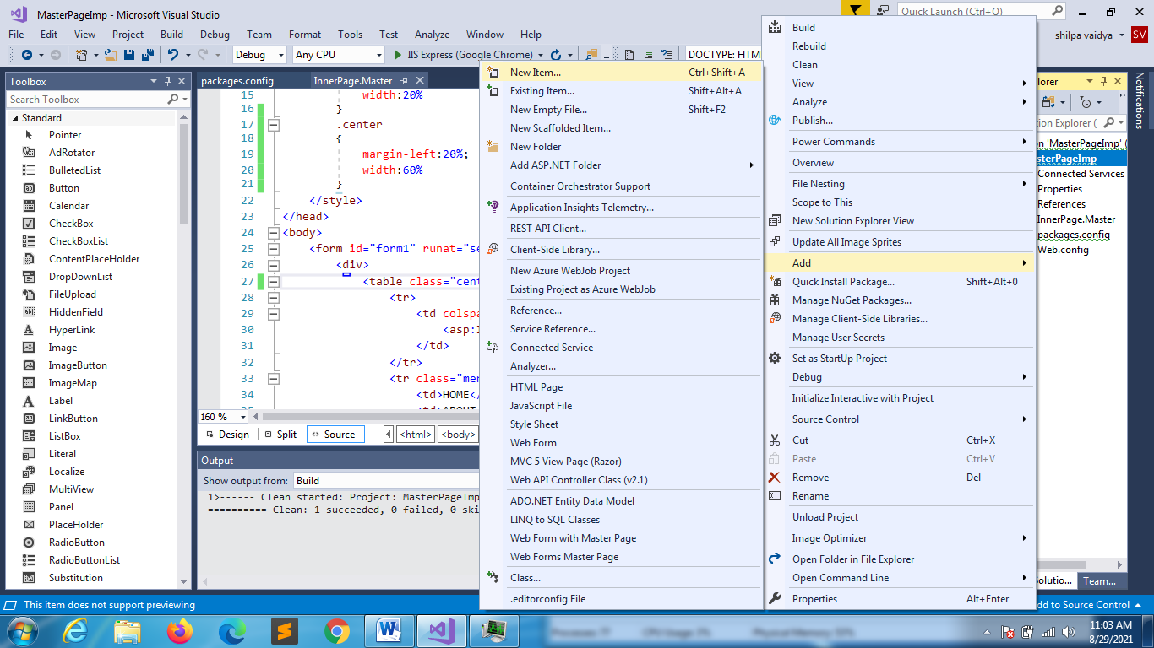

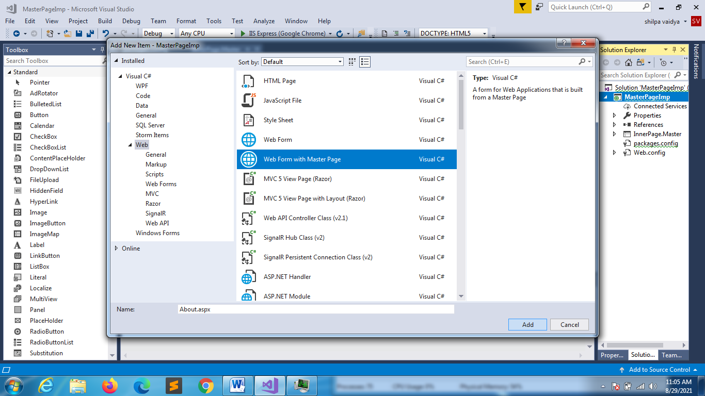

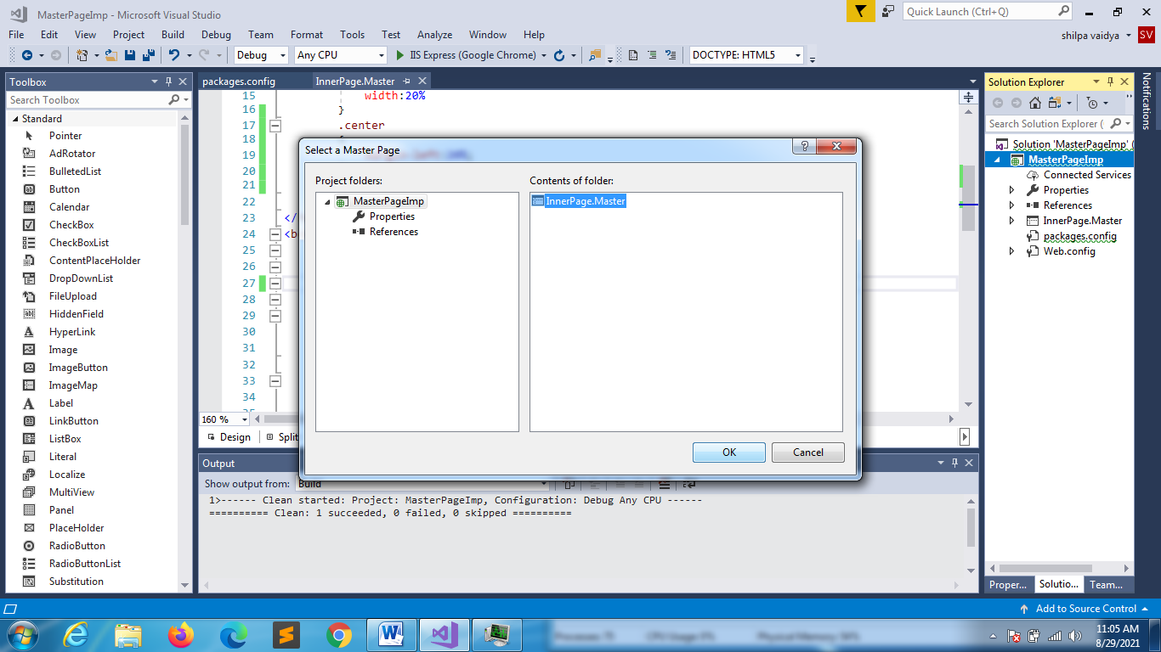

Add all the content

